Modelos no lineales: curva de aprendizaje en el sector textil

J. Ramajo

2020

library(readr)  
library(alr4)

#  
CURV_APR <- read_csv("CURV_APR.csv")

## Parsed with column specification:  
## cols(  
## T = col_double(),  
## X = col_double()  
## )

CURV_APR_ts <- ts(CURV_APR, start=c(1), end = c(60), frequency = 1)  
plot(CURV_APR_ts)

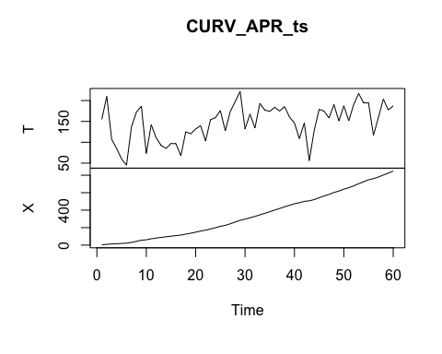

#  
curv.apr.dat <- cbind(CURV_APR_ts,lag(CURV_APR_ts[,2],-1))  
curv.apr <- data.frame(curv.apr.dat)  
names(curv.apr) <- c("T", "X", "LX")  
summary(curv.apr)

## T X LX   
## Min. : 45.0 Min. : 3.0 Min. : 3.0   
## 1st Qu.:119.5 1st Qu.:107.2 1st Qu.:107.2   
## Median :154.4 Median :305.0 Median :305.0   
## Mean :147.5 Mean :343.2 Mean :343.2   
## 3rd Qu.:180.1 3rd Qu.:547.0 3rd Qu.:547.0   
## Max. :221.8 Max. :847.0 Max. :847.0   
## NA's :1 NA's :1 NA's :1

#  
reg_nl <- nls(T~c1*(X^(c2+1)-LX^(c2+1)), data=curv.apr, start=list(c1=10, c2=-0.5))  
summary(reg_nl)

##   
## Formula: T ~ c1 * (X^(c2 + 1) - LX^(c2 + 1))  
##   
## Parameters:  
## Estimate Std. Error t value Pr(>|t|)   
## c1 47.03681 3.51182 13.39 <2e-16 ***  
## c2 -0.22414 0.01067 -21.00 <2e-16 ***  
## ---  
## Signif. codes: 0 '***' 0.001 '**' 0.01 '*' 0.05 '.' 0.1 ' ' 1  
##   
## Residual standard error: 13.21 on 57 degrees of freedom  
##   
## Number of iterations to convergence: 8   
## Achieved convergence tolerance: 1.031e-06  
## (2 observations deleted due to missingness)

coef(reg_nl)

## c1 c2   
## 47.0368087 -0.2241352

gamma <- coef(reg_nl)[[1]]  
delta <- coef(reg_nl)[[2]]  
#  
curve(gamma*x^delta, from=0, to=100, xlab="Unidades producidas", ylab="Costes medios" )

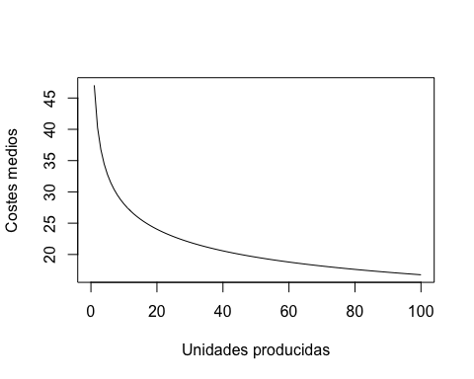

#  
set.seed(10131985)  
reg_nl.boot <- Boot(reg_nl, R=999)  
summary(reg_nl.boot)

##   
## Number of bootstrap replications R = 999   
## original bootBias bootSE bootMed  
## c1 47.03681 -0.6821217 8.862188 45.89781  
## c2 -0.22414 0.0045848 0.026252 -0.22071

confint(reg_nl.boot)

## Bootstrap bca confidence intervals  
##   
## 2.5 % 97.5 %  
## c1 35.3578189 74.5744203  
## c2 -0.2873914 -0.1839928

hist(reg_nl.boot, layout=c(1, 2))

